INFORMATION TECHNOLOGY
Paper Two
June 2013
KZN – DEPARTMENT OF EDUCATION

GRADE 11

TIME: 2 hours TOTAL: 100

INSTRUCTIONS AND INFORMATION:

- This paper consists of 6 questions and 7 pages of print.
- Answer ALL questions and write neatly.
- Number your answers exactly as the questions are numbered.

SECTION A
QUESTION 1
MULTIPLE CHOICE QUESTIONS [10]
Choose the appropriate alternative
1.1 Which type of cable is still used as TV cables and also used on some older networks?
A Fibre Optic cable
B Co-axial cable
C Shielded Twisted Pair cable
D Unshielded Twisted Pair cable
1.2 Which one of the following combination of components is found on the motherboard?
A Printer, Keyboard, Busses
B CPU, Busses, Mouse
C Hard Drive, System Clock, RAM
D CPU, RAM, ROM, Cache memory
1.3 Which device connects networks over longer distances when the signal strength weakens (attenuation)
and must be boosted?
A Modem
B Hub
C Router
D Repeater
1.4 Which of the following is not a typical example of a software program?
A Monitor
B Norton's Antivirus
C Internet Explorer
D MS Paint
1.5 What device is used to provide limited alternative power in the event of a power failure?
A UPS
B Modem
C Bluetooth Dongle
D Network Card

1.6 Magnetic fields can influence two cables if they are close to one another. This leads to data corruption or loss of
data. What is this phenomenon called?
A. Attenuation
B. Electro-magnetic interference
C. Eavesdropping
D. Crosstalk.
1.7 Which statement regarding CD-RW / DVD Rom drive is TRUE?
A The drive can read and write information to a DVD but can only read data from a CD
B The drive can only write data to a CD but can read and write data to a DVD
C The drive can read and write data to a CD but can only read data from a DVD
D The drive can read and write data on both a DVD and a CD

1.8 To switch on a computer in safe mode means
- No other person can obtain entry to the computer without a password.
- viruses cannot harm the computer
- All the drivers are loaded to repair faulty devices.
D. that only the minimum number of drivers is loaded.

1.9 The ALU is...
A the Amalgamated Linux Unix environment
B a register which stores arithmetic data
C a unit which performs mathematical calculation
D the way characters are represented in Unicode
1.10 The System Clock...
A is found on the desktop in the right hand corner
B is a quartz crystal in a chip on the motherboard
C is not necessarily needed to run the computer
D controls the speed for copying DVD's (10)

Question 2 [5]
Matching Question
Match Column A with Column B
Write down only the number and the letter corresponding to the answer of your choice, for example: 1.1 E

Column A |  | Column B
2.1. | Software that records things ranging from computer specifications to web sites visited and returns the information back to the creator of the software | A | Identity theft
2.2 | The time taken for the read/write head on the disk to position itself on the correct sector | B | Thunderbolt
2.3 | A new interface for connecting peripheral devices to a computer via an expansion board | C | Buffer
2.4 | Personal information is misused when someone else poses as you electronically | D | GIGO
2.5 | A device that conducts and disperses heat commonly produced by electronic equipment and components | E | Heat Sink
 |  | F | Spyware
 |  | G | Seek time

SECTION B
QUESTION 3 [20]
SYSTEM SOFTWARE
Answer the questions that follow.

Twilight Agency wishes to upgrade the current systems by purchasing newer computers or upgrading the components of the existing computers. You and your team of computer technicians were hired to advise and implement the action plan that Twilight Agency has put forth.

3.1 | A Staff member asks you if the company should upgrade from Windows XP to the latest operating system. You were asked to advise on issues regarding hardware and software if this upgrade was possible.
3.1.1 | The computers hard drive that used to work with Windows XP, no longer works with the newer operating system. Give a possible answer why this may be so. | (2)
3.1.2 | What is an operating system? | (3)
3.1.3 | List 3 functions of a computers operating system. | (3)
3.1.4 | One of the essential functions of an operating system is process management. What is process management? | (2)
3.1.5 | Where is an operating system stored? | (1)
3.1.6 | Briefly discuss how the operating system gets loaded when the computer is switched on. | (3)
3.2 | Computers have the ability to multitasking and multi-process which can take place in a computer system with a single CPU. Briefly explain how this is possible? | (4)
3.3 | The Task Manager in windows shows a lot of useful data in terms of resources and processes that are currently running. The screenshot shows that there are 1103 threads active. Define what a Thread is and give an example.  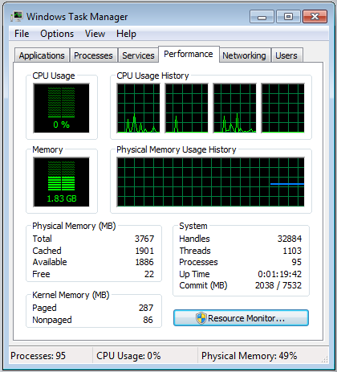 | (2)

QUESTION 4
HARDWARE/SOFTWARE/COMPUTER ARCHITECTURE [35]

Advert 1: R 5,699.00 | Advert 2: R 6,399.00
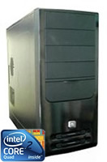  - Intel Core2Duo E7400 2.8Ghz  - 320GB Seagate SATAII HDD  - 2GB DDR2 800MHZ RAM  - 512MB Geforce 9500GT Graphics  - LG 22X CD Writer  - Intel Pearl Creek G31 MBD  Chassis with Front USB and 350W PSU  - Extras : PCI-Express slot + 6ch audio | 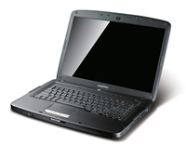  - 2.16GHz Dual Core CPU  - 15.4" BrightView LCD  - 2GB DDR2 memory  - 250GB Hard Drive  - DVD-Writer  - Webcam built-in  - Wireless Networking  - Windows Vista Home Premium  - 1 Year Acer Collect & Return Warranty
4.1 | When upgrading, Discuss the 3 most important hardware to consider that will improve the overall performance of your computer. Motivate your answer. | (6)
4.2 | What is meant by “Dual Core CPU” in advert 2? | (2)
4.3 | The head of the IT department of Twilight Agency suggests that purchasing new motherboard for  the computers will save on costs rather purchasing new PC. He has heard of a modular designed  motherboard.
4.3.1 | Briefly explain what a motherboard is and its function in a computer? | (3)
4.3.2 | State TWO components of the motherboard and explain why explain of those components play a vital role in the computer. | (4)
4.3.3 | What does the term Modular design mean? | (2)
4.3.4 | State 2 advantages of a modular design? | (2)
4.4 | The older computers that could have had contain cache memory.  Briefly define the term cache memory and explain how it works. | (3)
4.5 | One of the team members suggests that at least one computer should be fitted with a Firewire port.  Briefly describe the purpose of a Firewire port? | (2)
4.6 | Modern computers generally support the concept of ‘plug and play’. Briefly explain the meaning of this concept. | (2)
4.7 | The company also requires a scanner so that the client’s documentation can be scanned.  After the scanner is connected to a computer, a message indicates that the driver for the scanner is required.  4.7.2 What is a driver?  4.7.3 How can this problem be solved? | (1)  (1)
4.8 | All the computers make use of virtual memory when running software.  4.8.1 Briefly describe what virtual memory is.  4.8.2 Name two advantages of virtual memory. | (1)  (2)
4.9 | Many different processing techniques have been developed over the years to help the operating system and the CPU perform faster and more efficiently. Briefly describe the following processing techniques:  4.9.1. Multiprocessing  4.9.2 Hyperthreading | (2)  (2)
 |  | (35)

QUESTION 5 [15]
NETWORKS

Romano Computing sets up computer laboratories and networks and offers their clients a maintenance program. Your manager approaches Romano computing company about setting up a network for your company.

5.1 | Explain TWO advantages of having a network? | (2)
5.2 | The manager wishes to implement a client server network. Give TWO reasons why a Client Server network may not be such a good choice for the work place. | (2)
5.3 | Security is a major concern on a company’s network. Romano suggests we must employ a network administer. Explain what the role of a network administer is. | (2)
5.4 | There are various topologies that can be implemented in a Network. Which type of topology would you recommend to implement in the company. Motivate your answer. | (2)
5.5 | List the components that make up a network. | (2)
5.6 | Name the TWO functions of a Switch? | (2)
5.7 | Your CEO would like to have a wireless network instead of one using cables. He wants WiFi to be installed.  5.7.1 Explain the term WiFi.  5.7.2 If the WiFi technology is implemented, name the TWO devices that will be required to facilitate WiFi technology? | (1)  (2)
 |  | (15)

SECTION C
QUESTION 6
SOFTWARE DEVELOPMENT AND PROGRAMMING [15]
Below is a screen dump of a GUI from the software developed to calculate the cost per a car entering the KUNA MATATA Game Reserve. Study the GUI screen and then answer the questions that follow.
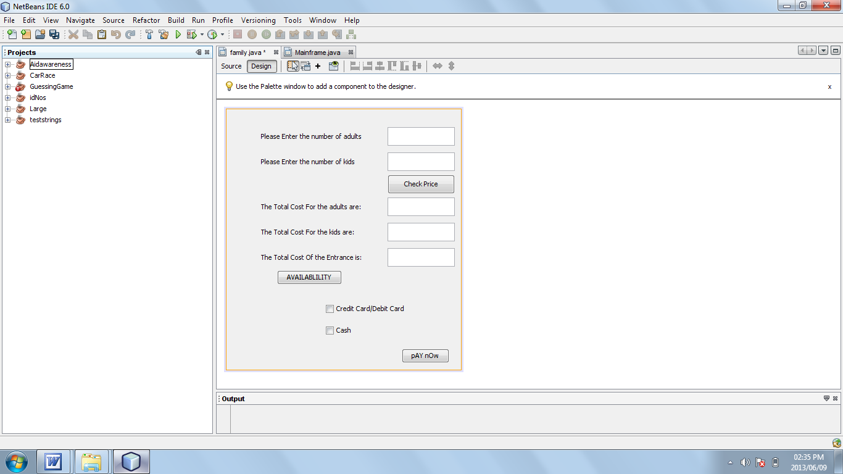

6.1 In the above screen, there is a GUI component that has been used incorrectly. Identify the incorrectly used GUI component and state why it is incorrect. (2)
6.2 Comment on the layout of the above GUI (2)

6.3 Answer the questions on the coding below:

1 | Double adult1 =Double.parseDouble(adult.getText());
2 | Double kids1 = Double.parseDouble(kids.getText());
3 | Double adultcost =adult1*25;
4 | Double kidcost =kids1 *10;
5 | Double totalcost = adultcost + kidcost;
6 | TotalAdults.setText (String.valueOf(adultcost));
7 | TotalKids.setText (""+kidcost);
8 | TotalCost.setText (""+totalcost);
9 | Double countppl = adult1 + kids1;
10 | if (countppl <=100)
11 | {
12 | JOptionPane.showMessageDialog(null,"Welcome To The Nature Reserve");
13 | }
14 | else
15 | {
16 | JOptionPane.showMessageDialog (null,"Sorry, we are full");
17 | System.exit(0);
 | }

    - What is the purpose of line 10? (2)
    - What is the function of String.valueOf? (2)

6.4 Computer experts emphasise the importance of the planning stages in programming. One way to plan effectively is to write out an algorithm.

6.4.1 Explain what an algorithm is. (2)

6.4.2 Explain why an algorithm designed in pseudocode should not be programming language specific. (3)

TOTAL MARKS: 100

